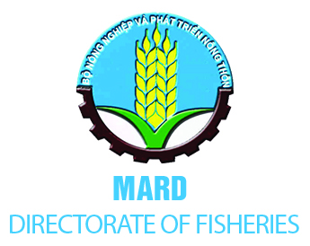 | 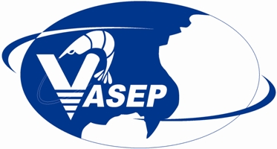 | 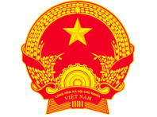  VIETNAMESE EMBASSY  TO THE KINGDOM OF BELGIUM & LUXEMBURG

PRESS RELEASE
VIETNAM’S EFFORTS AND COMMITMENTS TO COMBAT IUU FISHING
(Seafood Expo Global, Brussels 24-26th April 2018)

Following the EC notification letter dated 23rd October 2017 regarding the risk of Vietnam being identified as a non-cooperating country in combating IUU fishing according to EC Regulation No 1005/2008, Vietnam Government determined it as challenges as well as opportunities to improve and restructure Vietnam fishery industry with the aim to be modern, sustainable and responsible fishery, meeting the EC recommendations and regulations. As a result, the Government has improved legal framework as well as implementation of fisheries management and development in Vietnam.
On November 21, 2017, the National Assembly of Vietnam passed Law No.18/2017/QH14 (referred to as Fisheries Law 2017), of which, for capture and fishing vessel management (Chapter IV and V), the new law focuses on 9 EC recommendations. In particular, the Fisheries Law 2017 legislates the contents of IUU, including the recommendations of the European Union (EC). Articles 60 and 61 regulate 14 activities being considered to be illegal fishing that will be fined according to regulations. Also, MARD is speeding up the revision of decrees and circulars guiding the implementation of the Fisheries Law.
In order to implement urgent solutions to remove the warning on IUU fishing and maintain the prestige of Vietnam's seafood brand, on 13th December 2017, the Prime Minister issued Directive No. 45/CT-TTG requiring the ministers, the heads of the ministerial-level agencies, the Government agencies and the presidents of the provincial/municipal People's Committees to strictly obey regulations to combat IUU fishing. Before that, on 28th of May 2017, the Prime Minister had issued the official telegram No 732/CĐ-TTg on prevention, reduction and stopping of infringements by Vietnamese fishing vessels and fishermen regarding illegal fishing in foreign countries’ waters. As a result, the situation of fishing vessels and fishermen who illegally exploit marine products in foreign waters is significantly reduced. In particular, Vietnam fishing vessels in Pacific island nations have been reduced and almost stopped.
On 16 January 2018, the Prime Minister of Vietnam issued the Decision No 78/QĐ-TTg approving national plan of action to prevent, deter and eliminate illegal, unreported and unregulated fishing up to 2025.
The Minister of Agriculture and Rural Development issued Decision 670/QD-BNN-TCTS on implementing the Directive 45/CT-TTg of the Prime Minister on urgent duties and measures to overcome EU warning on IUU Fishing, and other Decisions and Legal Documents to give directives and guidances to 28 coastal provinces to take urgent measures to combat IUU fishing.
Recently, on March 23rd 2018, Minister of MARD Nguyen Xuan Cuong had a working session with Mr. Karmenu Vella, High Commissioner for Environment, Maritime Affairs and European Union fisheries in Brussels, Belgium. The Minister updated information on implementation of the EC recommendations on combating IUU fishing. The High Commissioner acknowledged the efforts of Vietnam.
As a key player in the seafood chain, VASEP and marine product companies in Vietnam have come early with a series of actions as well as cooperated with the Ministry of Agriculture and Rural Development, the Directorate of Fisheries and Vietnam Coast Guard to overcome the yellow card warning in the shortest possible time, implement long-term programs to combat IUU fishing, maintain the prestige and market for export seafood products of Vietnam.
On 25th September 2017, VASEP held the conference and announced the Press Statement: Vietnamese marine product enterprises committed to combating IUU fishing; The Association set up VASEP IUU Steering Committee and program to combat IUU fishing with almost Vietnam marine product companies joining the program. The companies are committed to strictly implementing the IUU regulations and the National plan of action to combat IUU fishing, to purchasing raw materials sourced from legal fishing vessels with clear traceability and only importing legally caught seafood.
On January 12th, 2018 VASEP officially released the "White Book on Combating IUU fishing in Vietnam" with the aim to disseminate information on Vietnam's efforts and solutions to tackle IUU. Besides, VASEP regularly updates the list of seafood enterprises that commit to combating IUU fishing on the website: www.vasep.com.vn in Vietnamese and English versions.
Following the action plan of the Program "Marine product enterprises committed to combating IUU fishing”, on Feb 1st 2018, Vietnamese marine product companies have simultaneously hung the board of commitments to combating IUU fishing at the gates or doors of their processing plants.
With the determinations and efforts, we believe and confirm the positive changes of Vietnam in the fight against IUU fishing and aiming to sustainable and responsible fisheries.

Directorate of Fisheries – MARD  Ms. Nguyen Thi Trang Nhung  Deputy Director  Department of Science and International Cooperation  Directorate of Fisheries, MARD  Email: trangnhungicd@gmail.com  www.tongcucthuysan.gov.vn | Vietnam Association of Seafood Exporters and Producers (VASEP)  VASEP MARINE PRODUCT COMMITTEE (VMPC)  Email: combat_iuu@vasep.com.vn  Hotline : +84 243.7715055 (ext:204) and +84.982195872  Website: http://seafood.vasep.com.vn/747/whybuy/combat-iuu-fishing.htm  Facebook: VASEP CombatIUU

