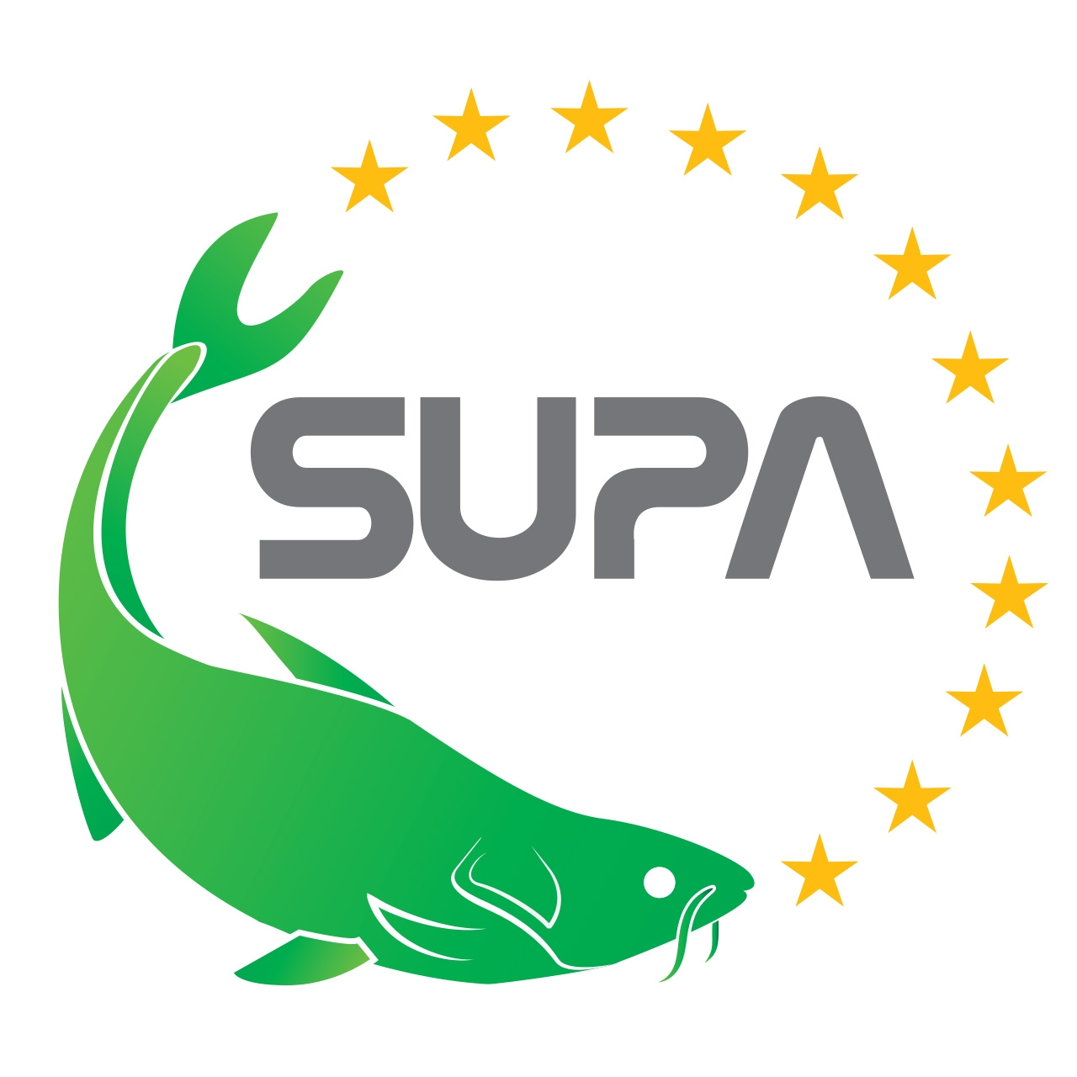 | 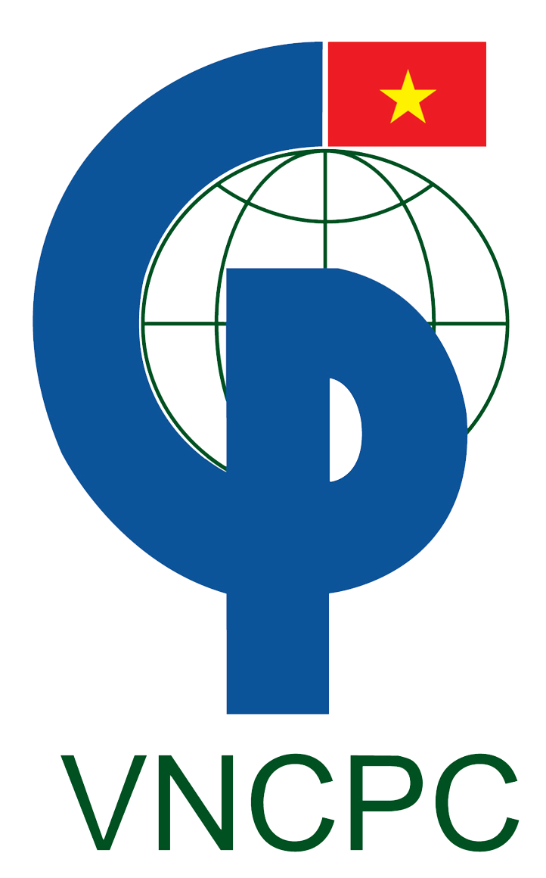 | 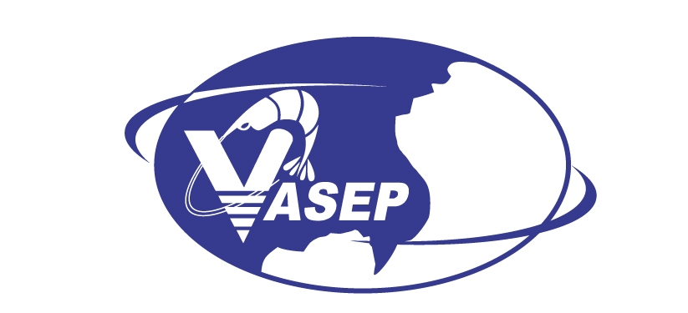 | 

SUPA’S PROGRAMME – VIETFISH FAIR (6-8, August 2014)
updated 15th July 2014
In the frame of the EC-cofunded project “Establishing a Sustainable Pangasius Supply Chain in Vietnam” (SUPA), the SUPA project partners are VNCPC, VASEP, WWF Austria and WWF Vietnam.
At the Vietfish Fair 2014, SUPA project, VASEP and Vietnam Pangasius Forum are co-organizers as well as in the partnership with ASC and CBI are hosting:
- The Pangasius farm and processing plant tour
- The “Vietnam Pangasius Forum - Vietfish 2014” with the topic “The sustainable growth for pangasius at European market”

1) Vietfish Fair  August 2014, Ho Chi Minh City, Vietnam |  | Remarks
a) SUPA booth: No.500&600, Hall A1  Date: 06-08 August 2014  Opening hours: 06 August 2014, 10:00-16:00  07 August 2014, 09:00-16:00  08 August 2014, 09:00-15:00  Venue: Saigon Exhibition and Convention Center – SECC  799 Nguyen Van Linh Ave., District 7, Ho Chi Minh City  General Website Vietfish Fair: http://www.en.vietfish.com.vn |  | Floor plan is attached
b) Vietnam Pangasius Forum - Vietfish 2014  The sustainable growth for pangasius at European market  Information sharing & lively discussions  Where producers meets buyer and vice versa!  Understanding and servicing consumer preferences!  Proudly promoting Pangasius – your everyday fish!  When: 06 August 2014, 14:00 - 16:30  Where: Hall 1 – 2nd Floor  Saigon Exhibition and Convention Center – SECC  799 Nguyen Van Linh Ave., District 7, Ho Chi Minh City  Objective:  - to hear about about efforts of the Vietnamese sector to invest in product quality;  - to join the way forward for proudly promoting pangasius towards consumers! |  | Organizers: VASEP, SUPA project and Vietnam pangasius forum  in the partnership with ASC & CBI  Facilitator: Mr. Nguyen Hoai Nam  Interpreter: Mr. Khang
14:00 - 14:10 | Welcome and introduction | Facilitator
14:10 – 14:20 | The targets for the sustainability development of pangasius at European market  Introduction of pangasius projects fostering the sustainability of the pangasius sector (SUPA, premium quality pangasius (with CBI), VIDATEC, MUTRAP). | VASEP
14:20 – 14:35 | SUPA activities to support a sustainable pangasius supply chain in Vietnam  Q & A | VNCPC
14:35 – 14:50 | The efforts and actions to improve and enhance the image of Pangasius products in the world market  Q & A | Dr. Pham Anh Tuan  Deputy General Director of D-FISH (MARD)
14:50 – 15:00 | FTA Vietnam - EU: Opportunities for the seafood sector  Q & A | Ms. Duong Phuong Thao  Deputy Director of Im- Export Dept. (MOIT)
15:00 - 15:15 | Break
15:15-15:30 | Pangasius Outlook at the EU market  Q & A | EU Importers/Retailer representative
15:30-15:40 | ASC certification and its impact on production and markets | Ms Esther Luiten  Manager Commercial Marketing, ASC
15:40 – 16:20 | Discussion round:  How to successfully promote responsible pangasius towards consumers and agree on a joint way forward  Panel list:  - D-FISH: Dr. Pham Anh Tuan - Deputy General Director  - MOIT: Ms Duong Phuong Thao - Deputy Director of Im-Ex Dept.  - NAFIQAD: Dr. Nguyen Nhu Tiep – Director of NAFIQAD  - VASEP: Mr. Truong Dinh Hoe - General Secretary  - SUPA: Mr. Le Xuan Thinh and Ms. Sabine Gisch-Boie  - EU delegation in Vietnam: Mr. Hoang Thanh  - Market expert: Mr Carson Roper
16:20-16:30 | Conclusion | VASEP

2) Pangasius farm and processing plant tour  Tue, 5th August 2014 |  | Organized by: SUPA
Objectives  - to visit an ASC certified pangasius farm and processing facility;  - to see with your own eyes how farming is done and how the farm and processing facility are managed;  - to see how the producer takes care of food safety, environmental & social responsible production and quality pangasius |  | Responsibility: VASEP
07:30-09:00 | - Departure at 07:30 am from Palace Hotel (Nguyen Hue blv, Dist 1, HCMC).  - Travel by minibus to Tien Giang Province (80 km from HCMC)  Godaco Seafood J.S.C  Lot 45, My Tho Industrial Park, Tien Giang Province  Confirmed person: Mr Nguyen Cong Binh  Im-Export Manager | Targeted group:  - EU importers and retailers delegation  - SUPA project’s partners.
9:00-9:30 | Short meeting with Company Managers
09:30-10:30 | Visit of processing facility at GodacoSeafood J.S.C
10:30-11:00 | Move from Godaco to their farm
11:00 – 11:45 | Visit of Pangasius Farm
12:00 – 14:00  14:00 - 15:45 | Lunch in Ben Tre  Travel back to Ho Chi Minh City

